Part 1

First I have installed Azure storage extension in Visual Studio Code, then in Azure in my storage account overview and I added two files index and 404.html

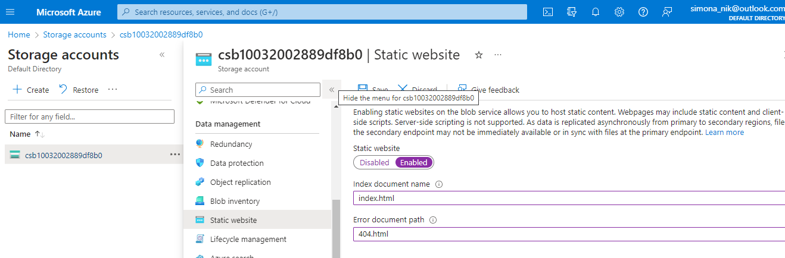

Next I created a Hello World web page with Visual Studio Code and deployed to the static website hosted in my Azure Storage account.

I have created an empty folder and then I have open it in VSCode and there I created two files:

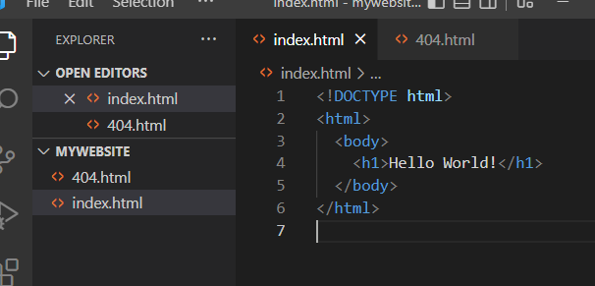

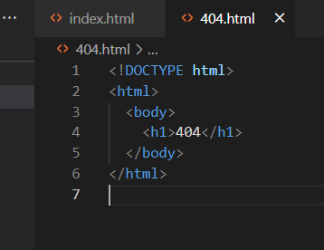

In the **Explorer** panel under the folder I selected **Deploy to Static Website** to deploy the website. I selected the subscription and the storage account when promted and Visual Studio Code uploaded the files to the web endpoint and to view it in Azure I have launched the website and the result is below

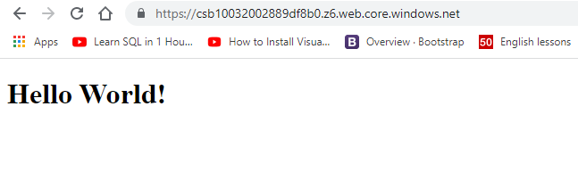

Part 2

In this task we need to setup a Linux based web server and will deploy a web page on it

First a Virtual Network is created:

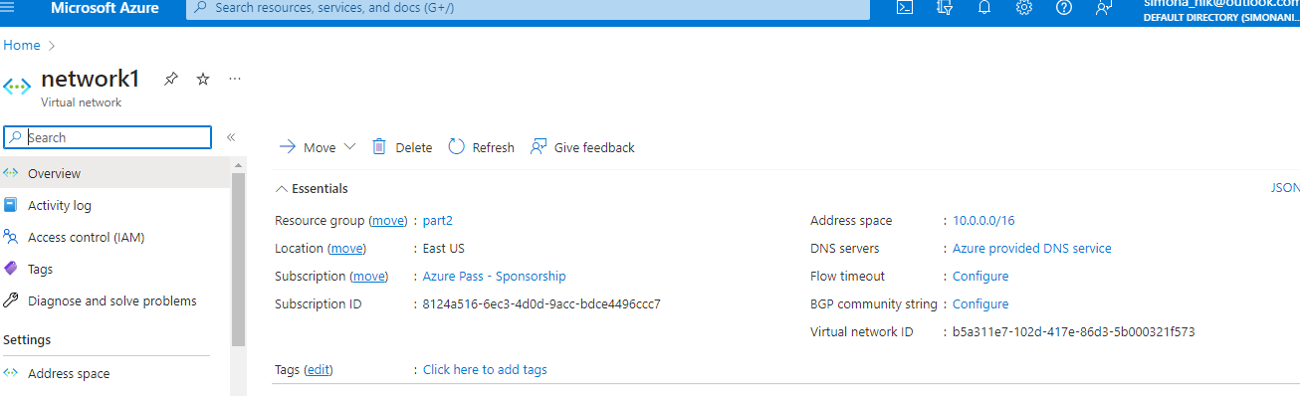

Then a network security group is created with an inbound rule:

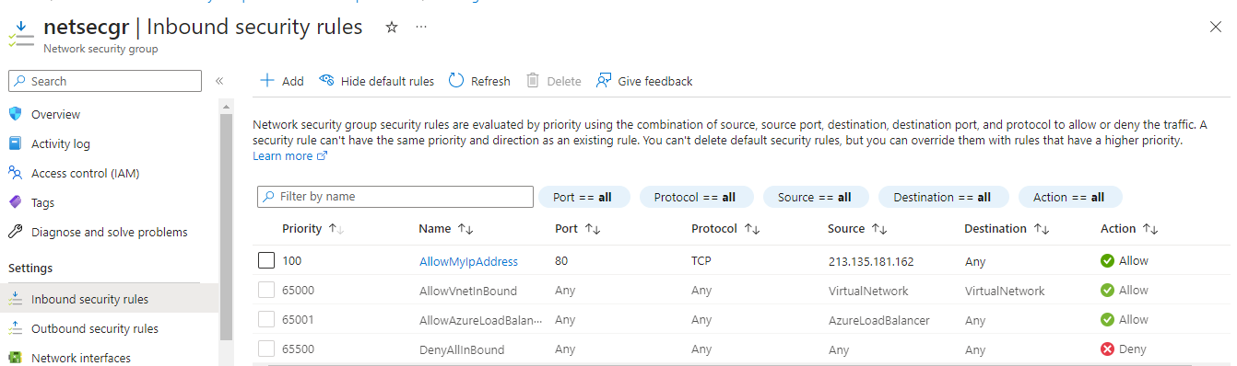

And a virtual machine:

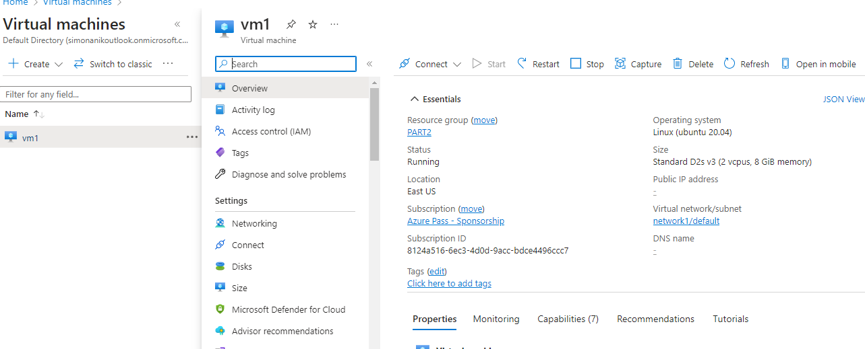

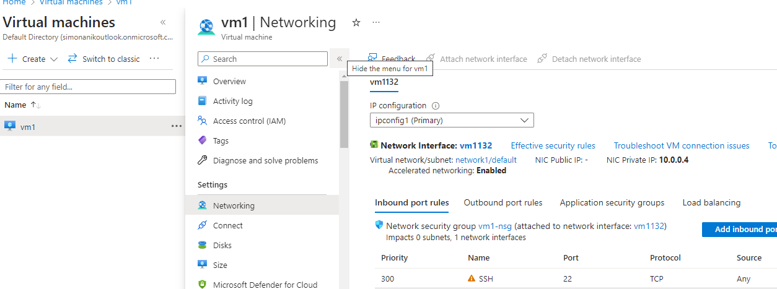

After connecting to the VM we need to install Apache Server with command: sudo apt install apache2 and the content of the index.html file needs to be replaced with Hello World:

